**U.S. Trading Partners Database SQL Commands and Notebook**

By: Anthony Wang

**Understanding the Data:**

* **In these tables:**
  + Table 1. U.S. International Trade by Countries - Exports of Goods and Services
  + Table 2. U.S. International Trade by Countries - Imports of Goods and Services
  + Table 3. U.S. International Trade by Countries - Balance on Goods and Services

Columns include: **Period**, Australia, Belgium, Brazil, Canada, China, France, Germany, Hong Kong, India, Ireland, Israel, Italy, Japan, "Korea, South", Malaysia, Mexico, Netherlands, Saudi Arabia, Singapore, Switzerland, Taiwan, United Kingdom, Vietnam, All other countries, European Union, "South/Central America".

The Period ranges from 1999 – 2023; The remaining columns are countries that represent the export, import, or balance amounts in millions of dollars, depending on the table.

* **In table 4 and 5:** 
  + Table 4. U.S. International Trade in Services by Major Category – Exports
  + Table 5. U.S. International Trade in Services by Major Category – Imports

Columns include: Period, Total, Maintenance and Repair Services n.i.e., Transport, Travel 1, Construction, Insurance Services, Financial Services, Charges for the Use of Intellectual Property n.i.e., "Telecommunications, Computer, and Information Services", Other Business Services, "Personal, Cultural, and Recreational Services", Government Goods and Services n.i.e.

The Period ranges from 1999 – 2023; The remaining columns are service categories that represent various types of international trade in services, measured in monetary terms (typically millions of dollars).

* **A close up of a text

  Description automatically generated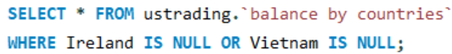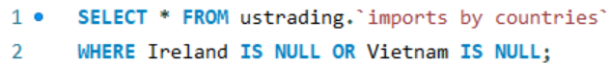Missing Values:**

**.**

**.**

**.**

**.**

Etc.

Ireland and Vietnam are missing export, import, balance amounts from 1999 to 2005

No missing values for both table 4 and 5: U.S. International Trade in Services by Major Categories - Exports and Imports

* **Anomalies**

We should start by looking at the International Trade Balance on Goods and Services Table. A positive value indicates a trade surplus, meaning the exports to a specific country exceed the imports from that country during the specified period. A positive balance means that the U.S. is earning more from trading with that country than it is spending. A negative value indicates a trade deficit, meaning the imports from a specific country exceed the exports to that country during the specified period. A negative balance means that the U.S. is spending more on imports from that country than it earns from exports.

When we look at the trade balance from 1999 to 2023, China and the European Union stand out as the biggest anomalies. Since 2005, the trade balance between China and the U.S. has consistently been less than negative 200 billion dollars, meaning the U.S. has imported over 200 billion dollars from China more than it exported to China. Ever since 2014, the trade balance has been less than negative 300 billion dollars. This can be explained the rapid growth of China's manufacturing sector, its role as a global export powerhouse, and the high demand for Chinese goods in the U.S. Goods include electronics, machinery, and consumer products. Furthermore, the U.S. has relied heavily on importing lower-cost goods from China to meet domestic consumption needs. On the other hand, the European Union has also shown a consistent trade imbalance with the U.S., although on a smaller scale. For most years since 1999, the trade balance with the European Union has been less than negative 90 billion dollars. This reflects strong economic ties and significant trade in high-value goods, such as automotive products, pharmaceuticals, and industrial machinery, with the U.S. importing more from the EU than it exports. The imbalance highlights the interconnected but asymmetric trade relationship between these economic powerhouses. The U.S. imports more from the European Union than it exports due to high demand for European luxury goods, advanced industrial products, and pharmaceuticals; U.S. exports more raw materials and services, and European Union has less demand for U.S. exports, so while U.S. service exports are significant, they cannot fully offset the deficit in goods trade.

Positive Trade Balances (surpluses) are generally viewed as favorable because they contribute positively to a country's GDP and reduce dependency on foreign goods/services. Negative Trade Balances (deficits) can indicate over-reliance on imports, but they aren't always bad. For example, importing critical goods or raw materials for production can be seen as good for economy.

**Overall Analysis:**

1. **Calculate a country’s trade volume between specific start and end dates:**

We will use Canada as an example here, but any country of interest can be selected for this calculation.

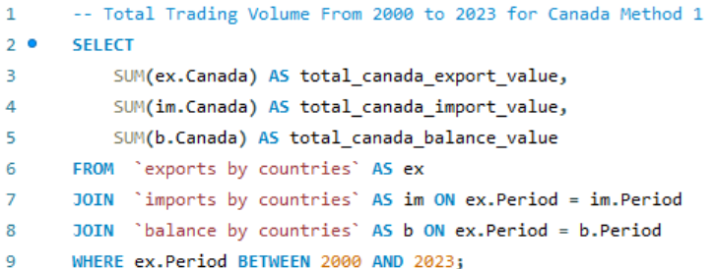Method 1:

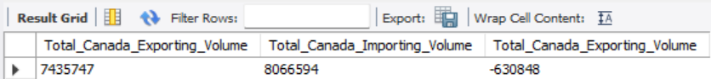Method 2:

1. A screen shot of a computer

   Description automatically generated**Display Export, Import, Balance Volume of a country in one table:**

**Trade Volume Analysis**

1. **Which countries have the highest total trade exports over the entire dataset?**

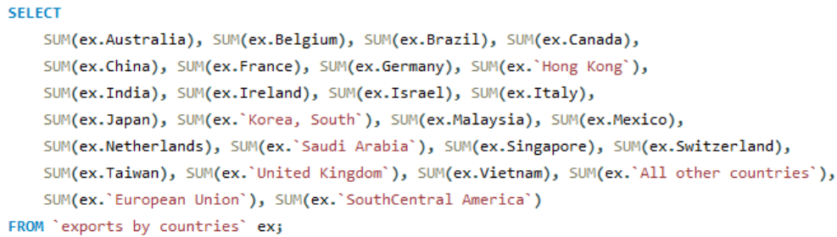 To display total exports volume for each country:

Total Exports volume for each country results:

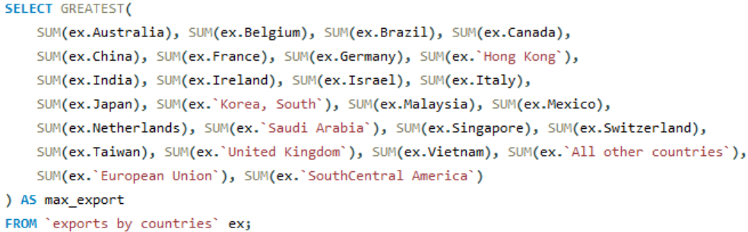To display the largest value among all columns, we use GREATEST statement:

Largest value is shown below, which corresponds to European Union:

1. **Which countries have the highest total trade imports over the entire dataset?**

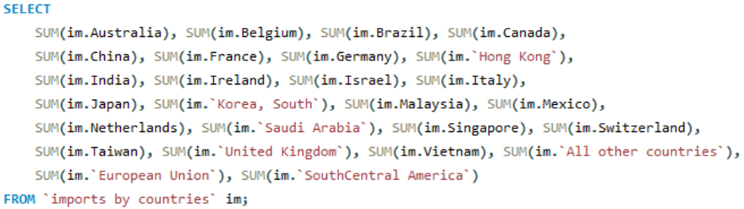To display total imports volume for each country:

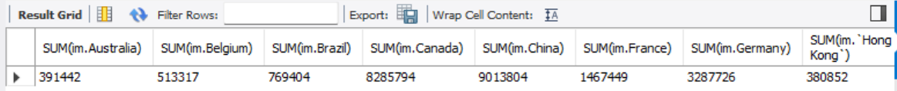Total imports volume for each country results:

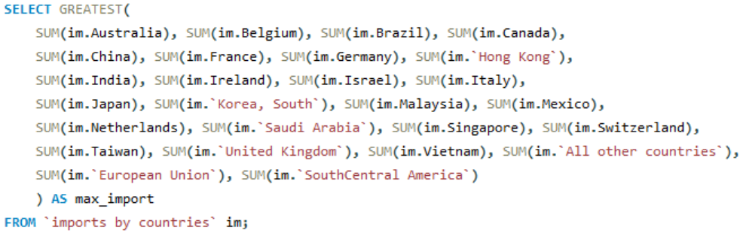To display the largest value among all columns, we use GREATEST statement:

Largest value is shown below, which corresponds to European Union:

1. **What are the top 5 countries by export volume?**

We need to unpivot and use “UNION ALL” to stack the results from multiple SELECT statements, and then transform results from columns into rows.

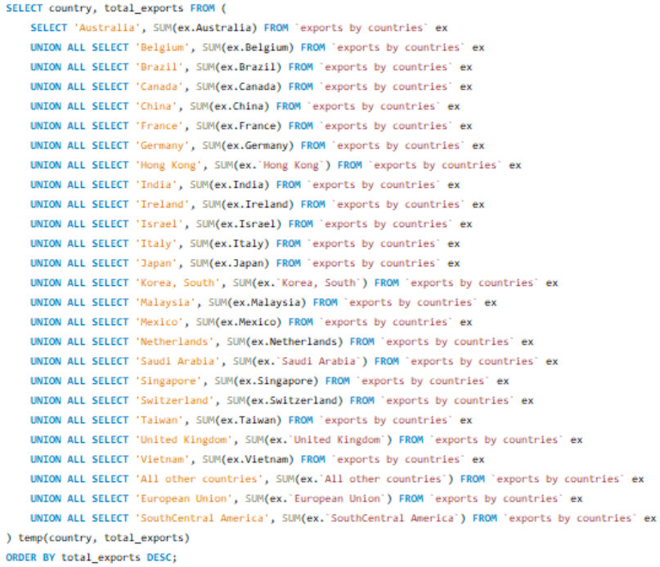

Output:

Therefore, the top 5 countries by export volume (from 1999 to 2025) are: European Union, Canada, Southern/Central America, Mexico, and China.

1. **Which countries have the largest trade deficits (imports > exports) and surpluses (exports > imports)?**

SUM(ex.country) – SUM(im.country) to get trade deficits, and then we create a temporary table to rank all countries.

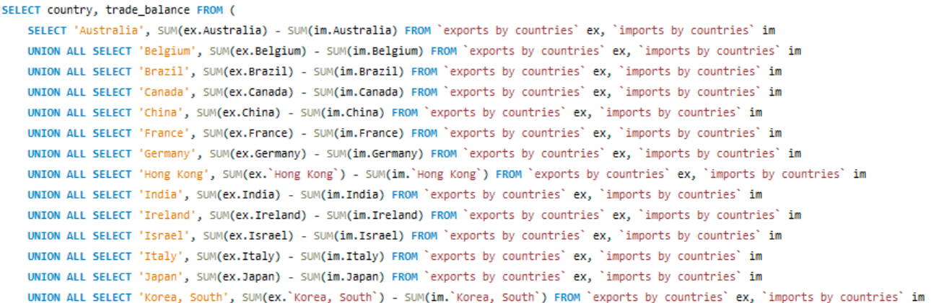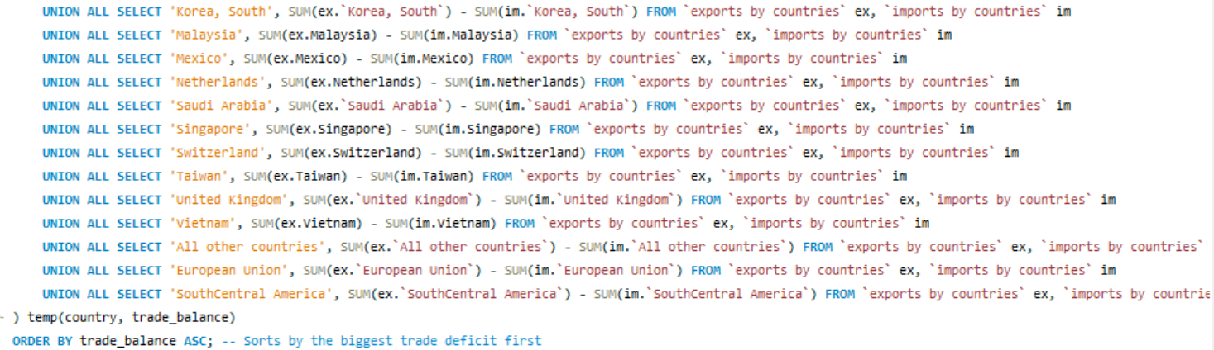

Output:

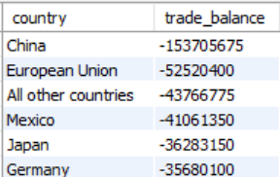

China, the European Union, Mexico, Japan, and Germany have the largest trade deficits. Negative numbers indicate a higher value of exports compared to imports. On the other hand, countries/regions like Brazil, Hong Kong, Australia, Netherland, South Central America have the largest surpluses. Those positive numbers demonstrate that these economies heavily rely on imports.

1. **A screenshot of a computer code

   AI-generated content may be incorrect.How have total exports and imports changed over the years for Canada?**

Output:

Both exports and imports have steadily increased over the years, indicating overall trade growth. In 1999, total exports for Canada were $190B, meanwhile imports were $219B. By 2023, exports reached $440B, while imports hit $481B. This significant change shows that Canada's trade volume has more than doubled in the last 25 years.

Canada has maintained a trade deficit (meaning imports > exports) for majority of the 25 years. The gap was small in the early years. For instance, in 1999, the deficit was around 29 billion dollars. The deficit widened after 2010. For example, in 2023, the gap was around 40 billion dollars. Overall, Canada’s trade has grown steadily, but the consistent trade deficit suggests that the Canadian economy needs stronger export policies.

**Regional Insights**

1. **What percentage of total trade is accounted for by specific regions or groups of countries?**

We will use European Union as an example here:

Total EU Trade=SUM(Exports) + SUM(Imports)

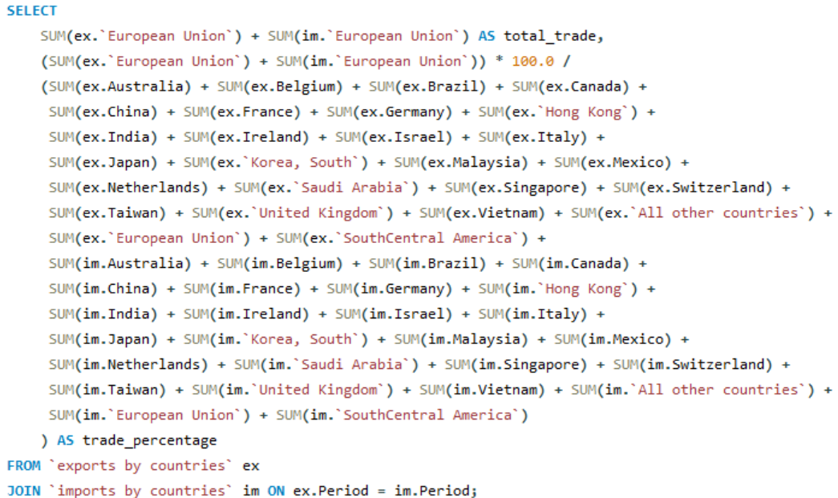

Output:

1. 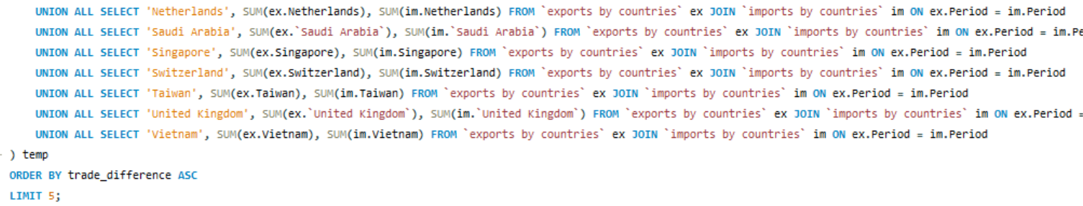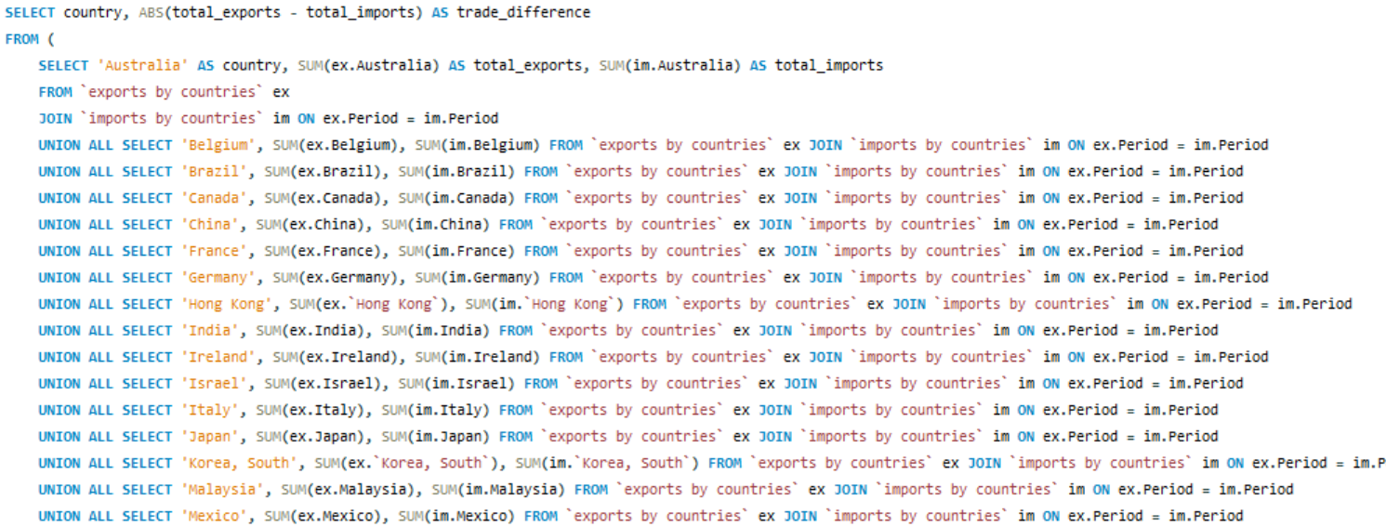**Which countries are the most balanced in their trade relationships?**

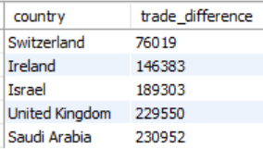Output: